**Personal information**

Background information: I was born and raised in Ho Chi Minh city. I was just a normal student for the 12 years of my study, my grade was never too low nor to high and the only language that I have learnt is English. I consider myself as an energetic person and I tend to put other people before myself in both work and life. Also, I love to make new friend along my journey and build new relationships. As for hobby, I’m really into video game as it has been a part of me seen my childhood.

**Idea jobs:**

Jobs links: https://itviec.com/it-jobs/blockchain-qa-engineer-up-to-3000-nextgen-blockchain-fzco-4213

Jobs description:

- Have a good understading on how popular dApps like : Uniswap, Sushiswap, Compound.. work.

- Have the ability in writing automated test for dApp is a plus.

- Capability to design a testing setup from scratch.

- be able to work alone.

- Must be able to make important decisions on their own.

- Must be able to self-motivated and creative in order to create the best methods for obtaining complete product test coverage.

**Personal profile:**

The results of an online Myers-Briggs test link: <https://my-personality-test.com/results/9967062813649118485/personality-type-indicator>

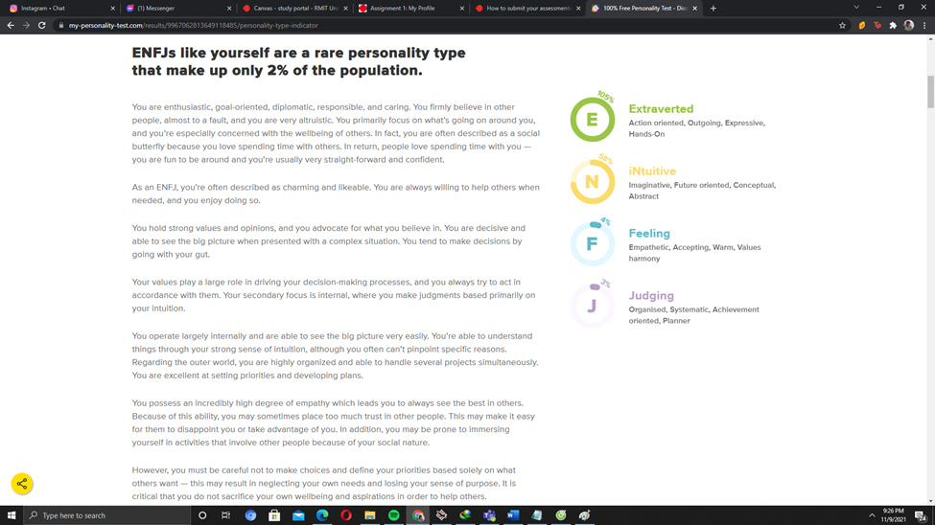

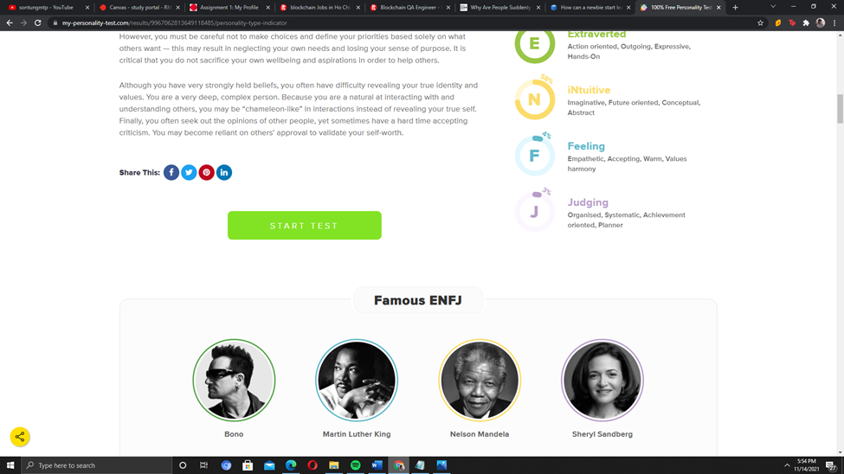

The results of an online learning style test link: <http://www.educationplanner.org/students/self-assessments/learning-styles-quiz.shtml?event=results&A=5&V=9&T=6>

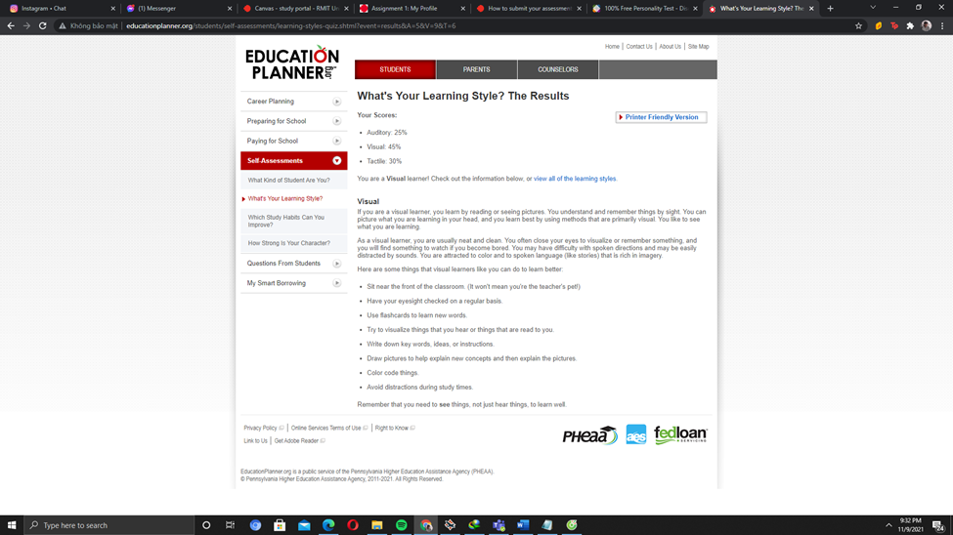

The result of one further online test of my choosing is the creativity test.

